1. ***Define the following terms:***
   1. ***Superclass of a subclass –***

It is defined as a class whose properties can be extracted by some other classes. Such class is defined as a superclass and the class that extracts its information is called as a subclass. Usually they are generic classes like People, Vehicle, etc.

* 1. ***Subclass***

It is a class that inherits the properties of a superclass, and is an extention of the same. They can be objects like Employee, Student, etc.

* 1. ***IS-A relationship***

The relation between the superclass and the subclass can be defined as ‘is-a’ relationship. In the above example, Employee is a Person. Here Employee is the sub class while Person is the super class.

* 1. ***Specialization***

Specialization can be defined as creating new entities from a given entity. A Person can be sub categorized to Employee as well as Student. Such a mapping of super class and sub classes is called specialization.

* 1. ***Generalization***

It can be defined as extracting key resources or attributes from two or more entities and combining them to form a single entity or super class. For an organization, Person is not required, while Employee entity is much required. Here all attributes are used in Employee and data redundancy is followed.

1. ***Consider the BANK ER schema in the below Figure, and suppose that it is necessary to keep track of different types of ACCOUNTS (SAVINGS_ACCTS, CHECKING_ACCTS, ...) and LOANS (CAR_LOANS, HOME_LOANS, ...). Suppose that it is also desirable to keep track of each ACCOUNT’s TRANSACTIONS (deposits, withdrawals, checks, ...) and each LOAN’s PAYMENTS; both of these include the amount, date, and time. Modify the BANK schema, using ER and EER concepts of specialization and generalization. State any assumptions you make about the additional requirements.***

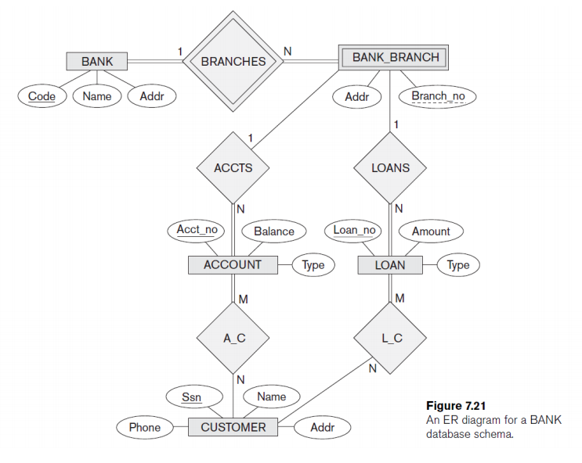

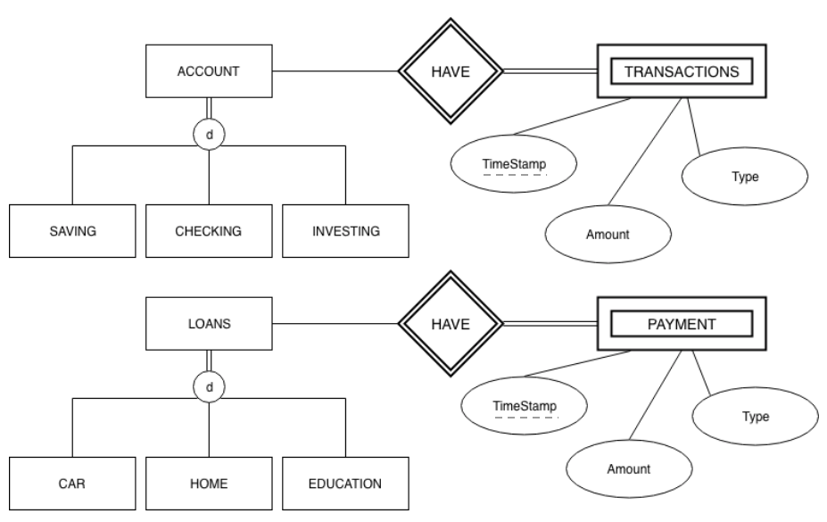

1. ***Consider the entity sets and attributes shown in the table below. Write your answer in the middle column of each row to indicate the relationship between the left and right columns.***
   1. ***The left side has a relationship with the right side***
   2. ***The right side is an attribute of the left side***
   3. ***The left side is a specialization of the right side***
   4. ***The left side is a generalization of the right side***

|  |  |  |
| --- | --- | --- |
| **Entity Set** | **Answer** | **Entity Set or Attribute** |
| Mother | Mother is a specialization of Person | Person |
| Daughter | Daughter has a relationship with Mother | Mother |
| Student | Student is a specialization of Person | Person |
| Student | Student_id is an attribute of Student | Student_id |
| School | School has a relationship with Class_room | Class_room |
| Animal | Animal is a generalization of Horse | Horse |
| Employee | SSN is an attribute of the Employee | SSN |
| Horse | Age is an attribute of the Horse | Age |
| Furniture | Furniture is a generalization of Chair | Chair |
| Chair | Weight is an attribute of the Chair | Weight |

1. ***Try to map the relational schema in the Figure below into an ER schema. This is part of a process known as reverse engineering, where a conceptual schema is created for an existing implemented database. State any assumptions you make.***

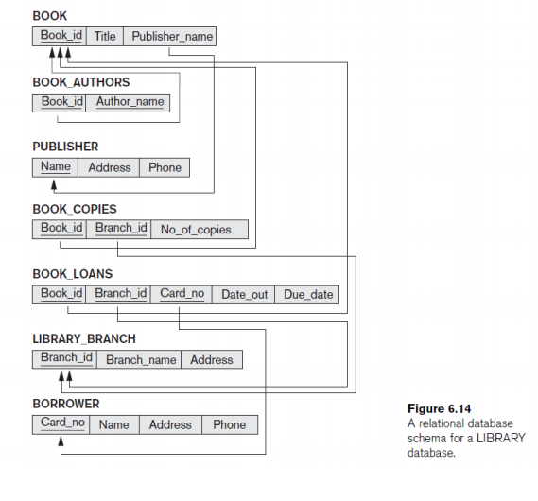

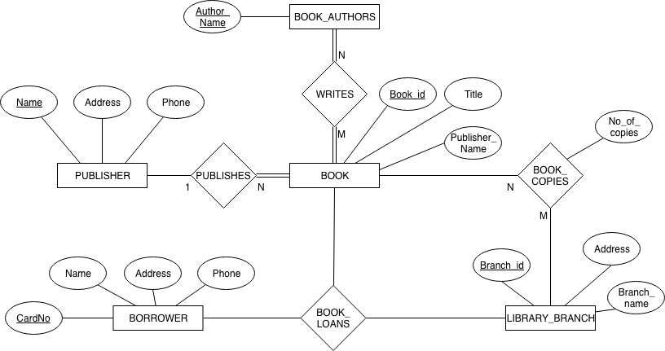

1. ***Figure below shows an ER schema for a database that can be used to keep track of transport ships and their locations for maritime authorities. Map this schema into a relational schema and specify all primary keys and foreign keys.***

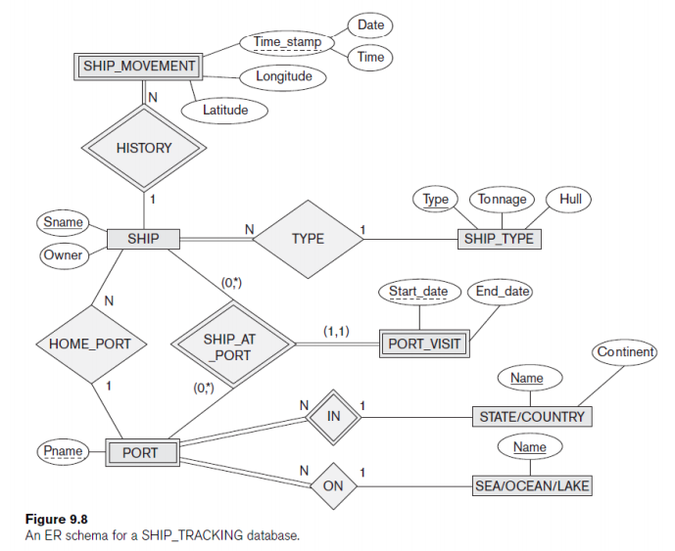

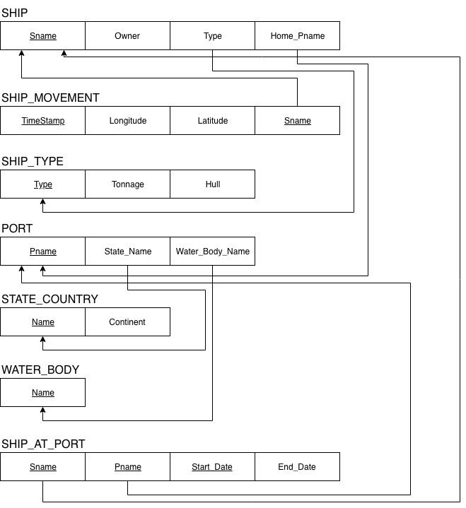

1. ***Is it possible to successfully map a binary M:N relationship type without requiring a new relation. If yes, depict it from the below diagram.***

No, it is not possible to map a binary M:N relationship type without requiring a new relation. Say we have the following entities:

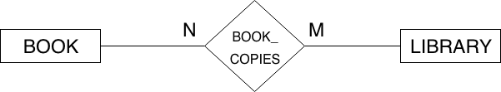

Having foreign key specification in any of the ends, would generate in Primary Key Integrity Constrain. This is due to cartesian product generated which will have multiple books with same IDs or multiple Library IDs. All these records can be held in a new relation which would consist of N*M records. Such relations are called Bridge Entities.

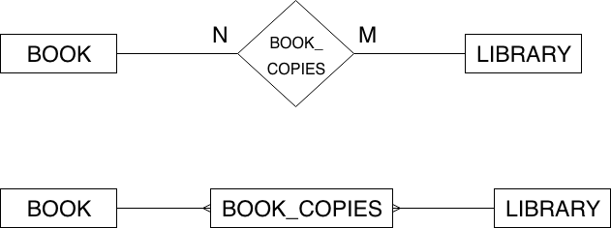

**References**

* <http://journals.ecs.soton.ac.uk/java/tutorial/java/javaOO/subclasses.html>
* Fundamentals of Database Systems, Sixth Edition by Elmasri, Navathe.